**Add a multi-step form to your page**

Follow the steps to create an advanced form in the Portals Management app and add it to a page in the design studio.

1. Go to [Power Pages](https://make.powerpages.microsoft.com/).
2. In the design studio, use the Data workspace to create/edit forms to use in each step of your process.

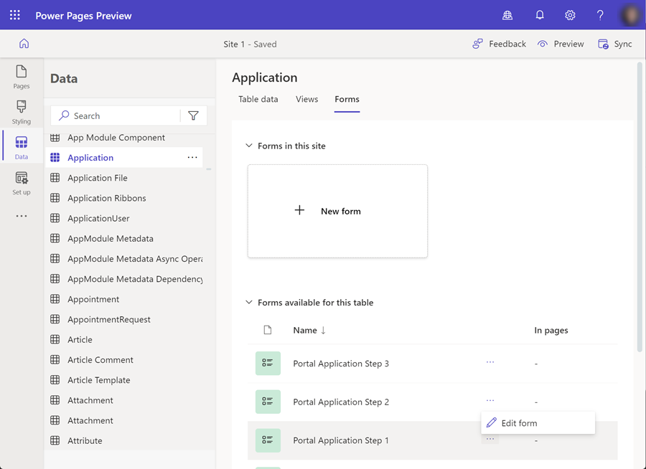

1. Publish your forms.
2. Advanced form configuration is done in the **Portal Management app**. Select the ellipses **...** from the left toolbar and select **Portal Management**.
3. In the Portal Management app, locate **Advanced forms** in the **Content** section. Create a new Advanced forms record.
4. Specify the configurations.
   * **Name** can be anything descriptive.
   * Set the **Website** is your website (press **Enter** to view list of sites).
   * **Start Step** will be blank for now, we'll set the start step later in the tutorial.
   * Set **Authentication required** to **Yes** (this will required your users sign in to the site to use the advanced form).
   * Set **Start new session on load** to **No** (this will allow your users to pick up where they left off in the advanced form steps).
   * Set **Multiple records per user permitted** to **Yes** (this will allow your users to use the advanced form multiple times to create multiple submissions).

Optionally, you can enable the **Progress Indicator** (scroll down) to show users their progress when filling out a form.

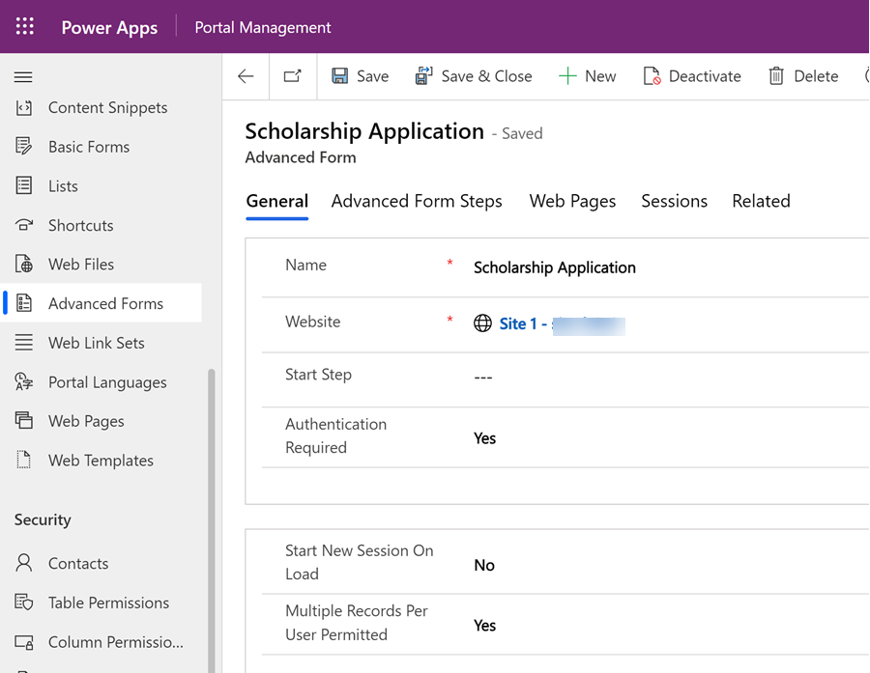

1. Select **Save**.

**Add advanced form steps**

1. In the **Advanced form steps tab**, create a **new Advanced form step record**.

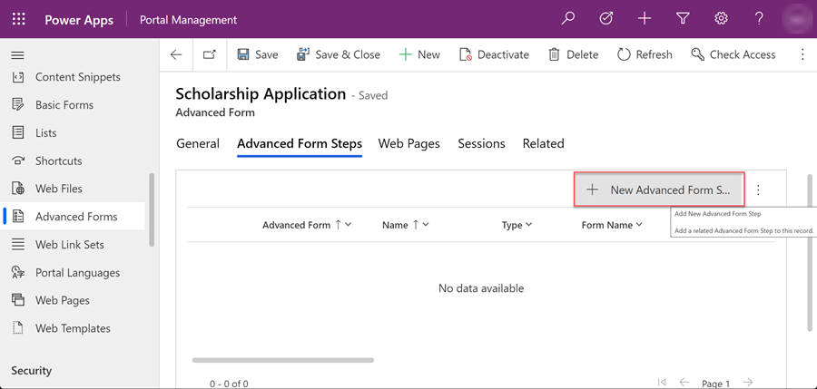

1. Specify the configurations.
   * Set **Type** to **Load Form**.
   * Select the **Target Table name** from the drop-down menu.

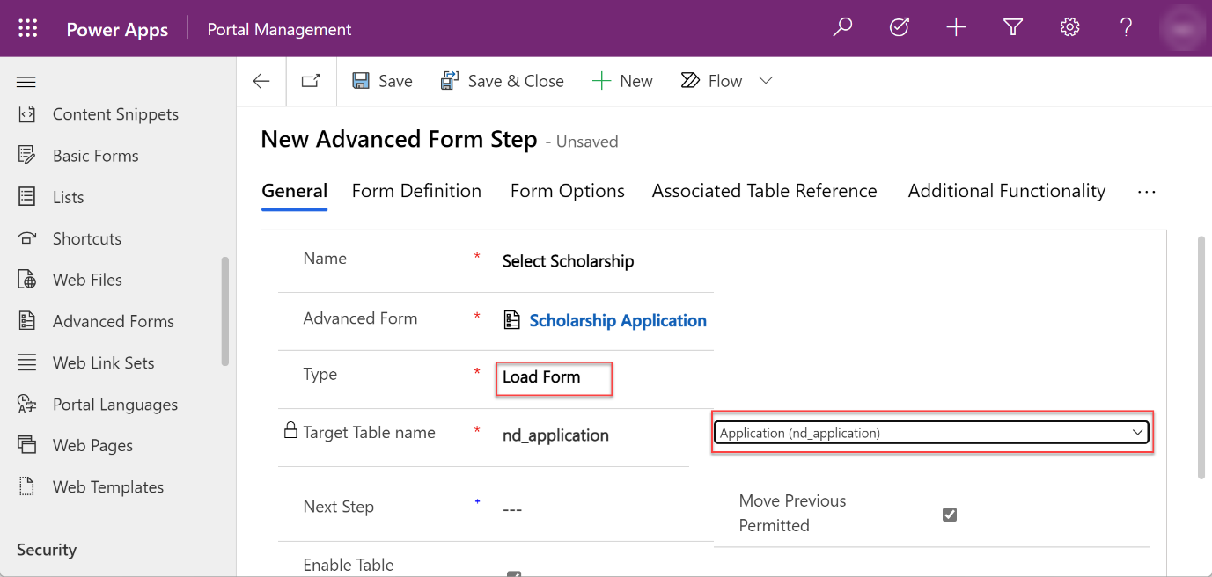

1. Select the **Form Definition** tab where we'll add more configuration.

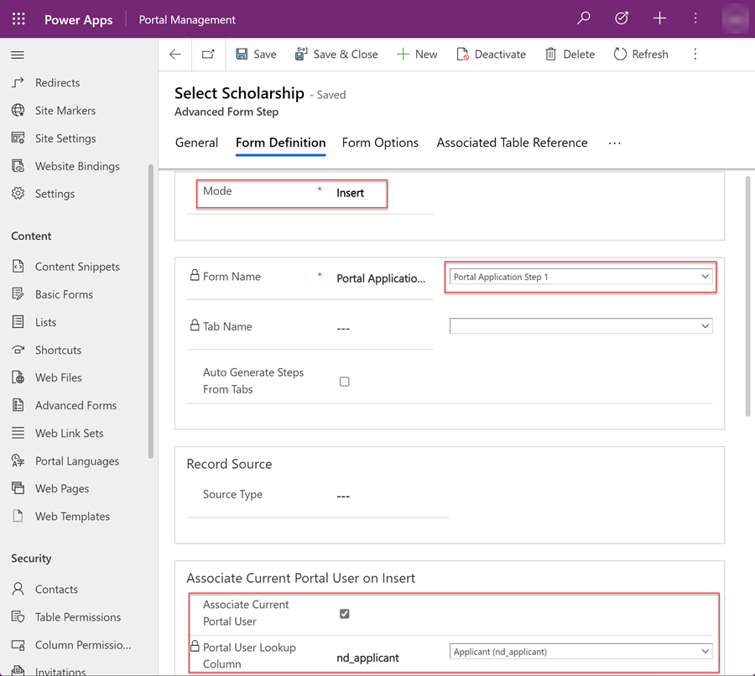

1. Set the **Mode** to **Insert**. This means that this step will *create* a new record in the table as part of the process.
2. Scroll down the page and select the **Form Name** from the drop-down menu.

**Note**

If you created a form with a set of tabs for each step, select the appropriate **Tab Name** for the step.

1. Scroll down the page and select the **Portal User Lookup Column** from the drop-down menu. This will associate the currently signed-in user with the record being created. The table will need to have a lookup field to the contact table.

**Adding edit steps to your advanced form**

You can edit existing records in advanced forms. These may be a record you created earlier in the process. For example, we created a record in the first step, and now we want to collect some additional information in a subsequent step.

1. In the **Advanced form steps tab**, create a **new Advanced form step record**.



1. Specify the configurations.
   * Set **Type** to **Load Form**.
   * Select the **Target Table name** from the drop-down menu.
2. Select the **Form Definition** tab where we'll add more configuration.

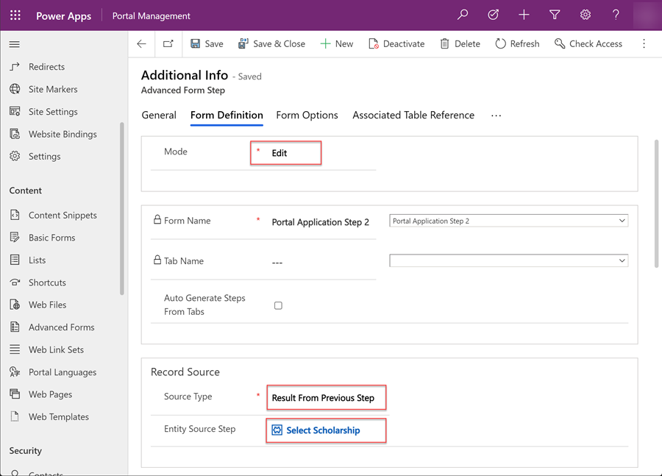

* + Set the **Mode** to **Edit** as we're now updating a record.
  + Choose the form (and if necessary, the tab) where the user will be editing or adding data to an existing record.
  + Set the **Source Type** to **Result From Previous Step**. This step will provide the GUID of the record we need to edit as part of the step. There are other options to specify the source record.
  + When the **Source Type** is **Result From Previous Step**, we need to specify the step in the process that will indicate which record is being edited.

1. Select **Save**

**Adding conditions to your advanced form**

If you need to add conditional logic to your advanced form, identify the condition by adding the Dataverse column logical name and the evaluation you want to perform. The logical name of a column can be found by viewing the column configuration in [Data workspace](https://learn.microsoft.com/en-us/power-pages/configure/data-workspace-tables).

In the steps below, we'll check to see if an applicant is pursuing a Masters degree. If a user is pursuing an advanced degree, they'll be directed to extra steps. Other applicants will skip that step.

1. In the **Advanced form steps tab**, create a **new Advanced form step record**.



1. Specify the configurations.
   * Set **Type** to **Condition**.
   * Select the **Target Table name** from the drop-down menu. 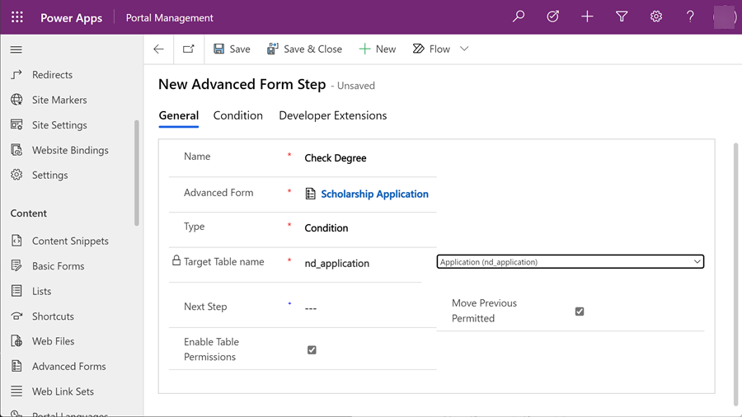
2. Select the **Condition** tab and enter the condition using the logical column name and a value.

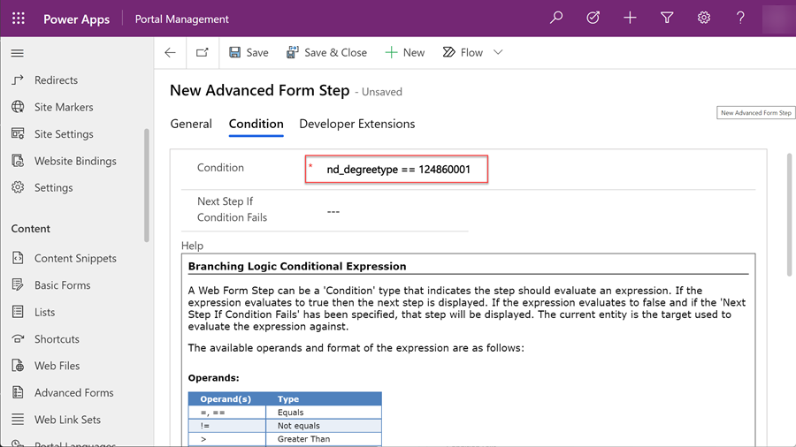

1. Select **Save**

Repeat the instructions outlined until you've created the number of steps needed for your business process.

In the example, we have created the following steps for the scenario of applying for a scholarship.

| **Step** | **Type** | **Mode** | **Details** |
| --- | --- | --- | --- |
| Choose Scholarship | Load Form | Insert | * Creates an application record * User chooses scholarship |
| Application Details | Load Form | Edit | * User adds details to application * User fills in degree type choices that will be used to determine condition in next step. |
| Check Degree Type | Condition |  | * Evaluates degree type choices using column logical name. * Next step is Master degree information if *true* or Consent step if *false*. |
| Master Degree Information | Load Form | Edit | * Allows user to fill in additional information if they selected a degree type of *Master* in a previous step, this step is skipped if degree type selected was *Bachelor*. |
| Consent | Load Form | Edit | * Allows user to choose consent field and ends process. |

**Link the steps**

Once the steps have been created, you'll need to first go back and specify the start step and link all the steps you created previously.

1. Open the Advanced Form record.
2. Choose the appropriate Advanced form step for **Start Step**

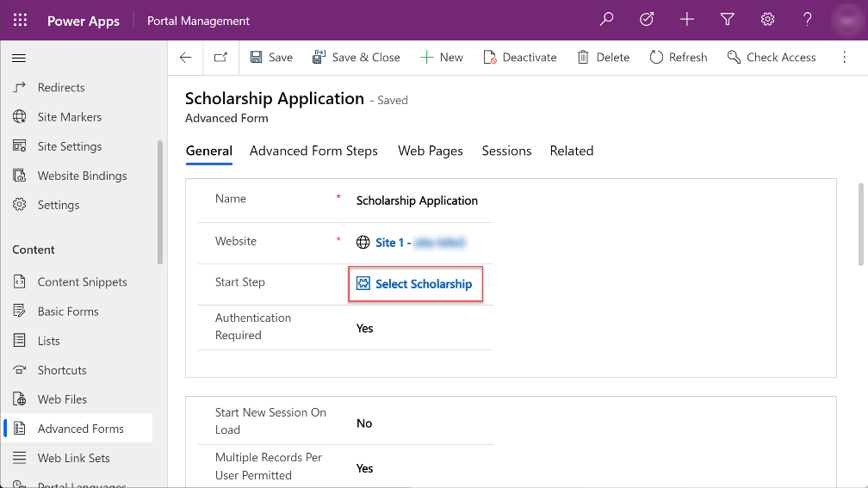

1. For each step, ensure the **Next Step** is populated, except for the last step.

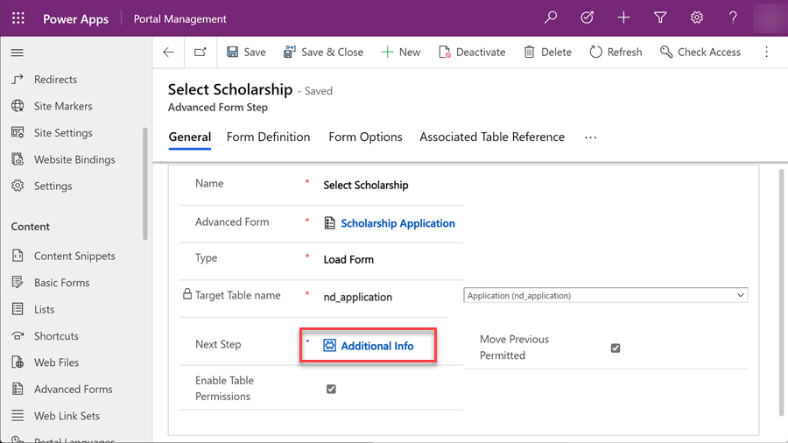

1. Conditional steps will have two targets, the step if the evaluation has passed and a step if the evaluation hasn't passed.

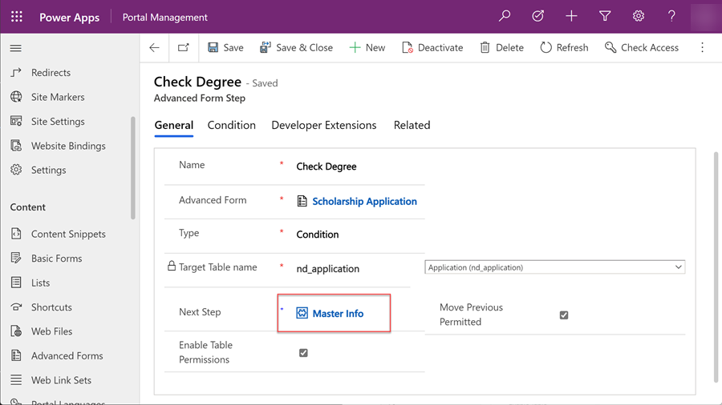

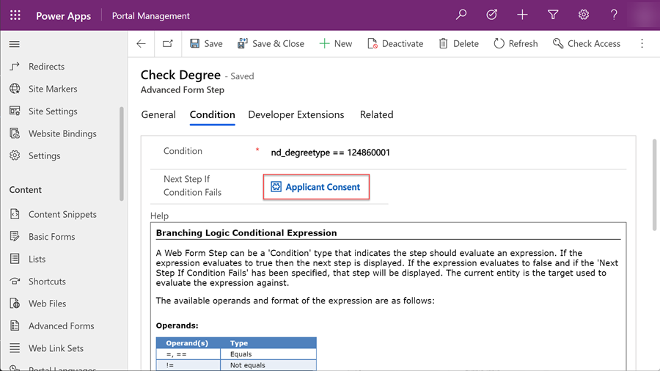

1. With conditions, the multiple steps may lead to a step, some of which may **not** have been surfaced to the user. The **Record Source** should be set to a previous step earlier in the process that the user would have interacted with. This is to make sure that the record being updated is identified.

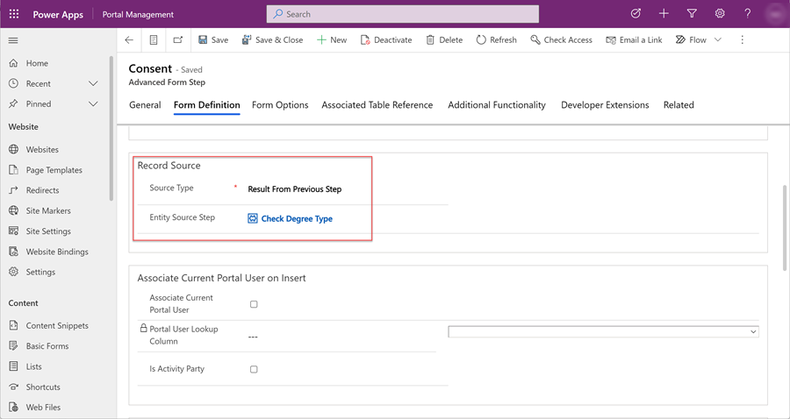

**Table permissions**

Ensure that you've created all the appropriate table permissions for the tables where records are being created, modified or associated with (for example, populating a lookup).

**Add configuration options**

Advanced forms can be configured for different behaviors, set default values, and specialized user controls. In the following example, we'll replace a lookup column with drop-down control as it would provide a better experience for a user.

1. In the **Portal Management app**, choose **Advanced form**, then in the **Advanced Form Steps** tab, select the appropriate step.

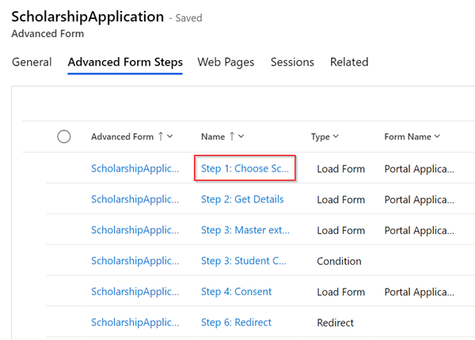

1. In the **Related tab**, choose **Metadata**.

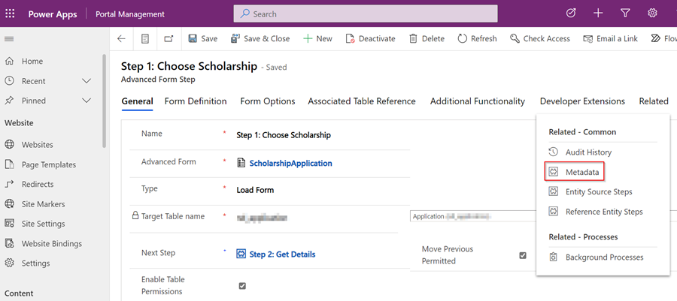

1. Choose **New Advanced Form Metadata**.

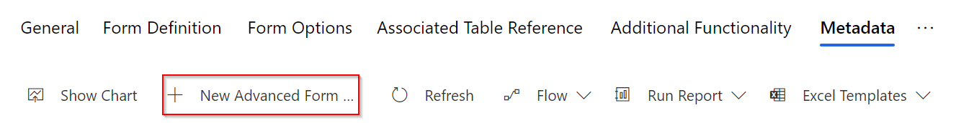

1. Set the **Attribute Logical Name**.

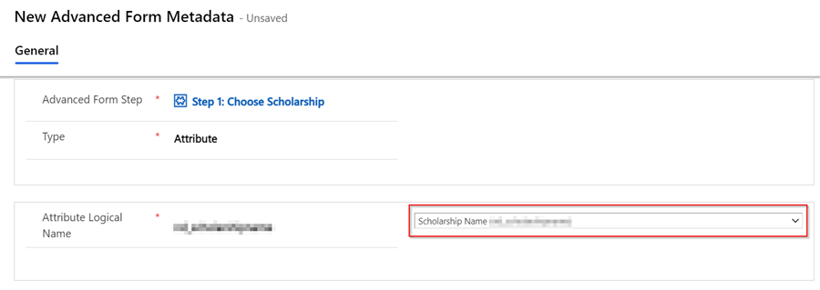

1. Scroll down to **Control Style** and set the **Style** to **Render Lookup as a Dropdown**.

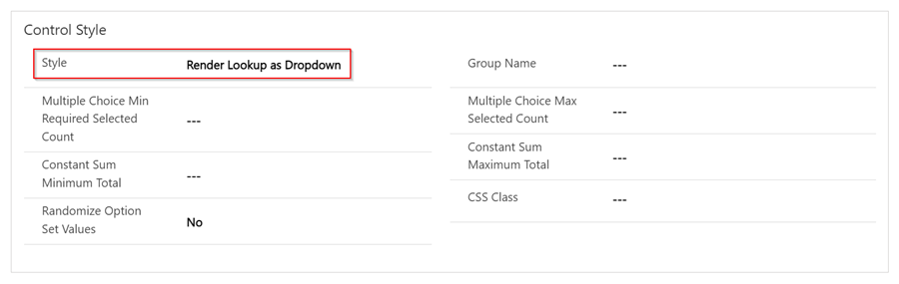

**Add an advanced form to a page**

Now that we've created an advanced form in the Portal Management app, we can now add it to a page in our site.

We'll need to use the code editor to add a [Liquid](https://learn.microsoft.com/en-us/power-pages/configure/liquid-overview) tag to the page to show the advanced form.

1. Open the design studio and **Add a page** or edit a page to which you want to add the advanced form.

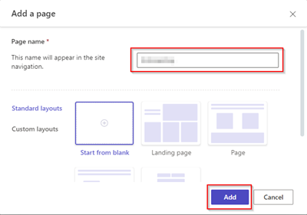

1. Open the **code editor** by selecting the **</>** at the top of canvas.

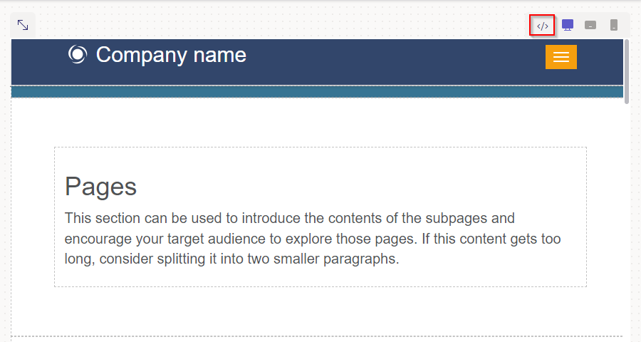

1. Select the code editor icon, and in between the <div></div> tags, enter in the following Liquid code snippet:

{% webform name: '<name of advanced form>' %}

For example, if your advanced form name was *Scholarship Application* then the code would be:

{% webform name: 'Scholarship Application' %}

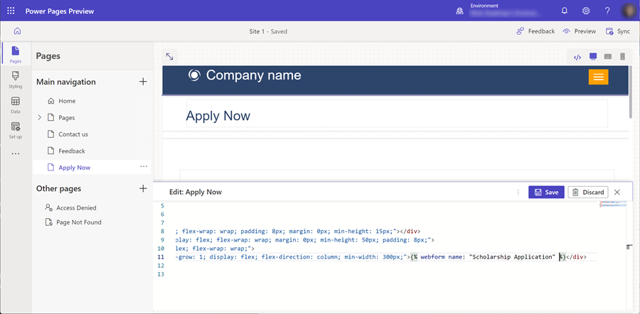

1. Select **Save**.
2. Select **Preview**.
3. Sign-in to your site.
4. Fill in and test your form.

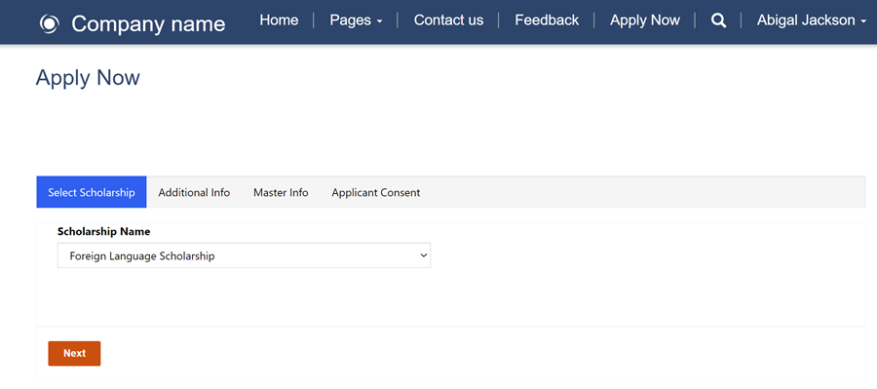

1. You can view the information collected and updated in your advanced form by going to the Data workspace table designer, selecting the table, and viewing the data.